I have 2 instances of postgres running on my local machine. SO it was confusing at first which instance I was connecting to.

I used \conninfo to check the instance I am currently connected to and realized the ports were different.

Both instances have default db called postgress

In order to connect with the right instance you must specify the right port.

First Step: Connect to a postgres instance and create a database
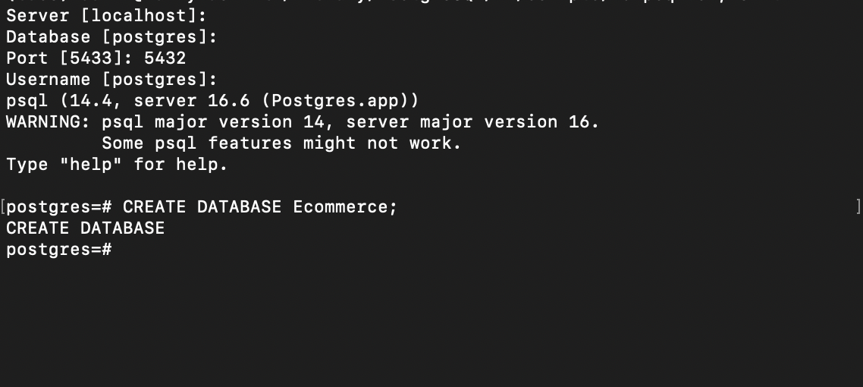

Check the lists of db currently on the instance and confirm the creation of Ecommers db
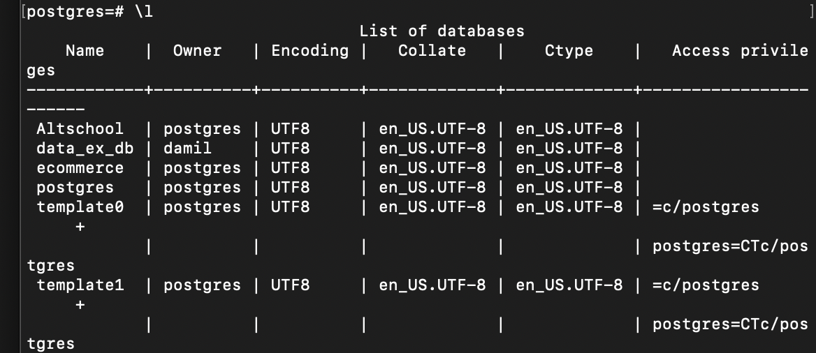

Schema Design.
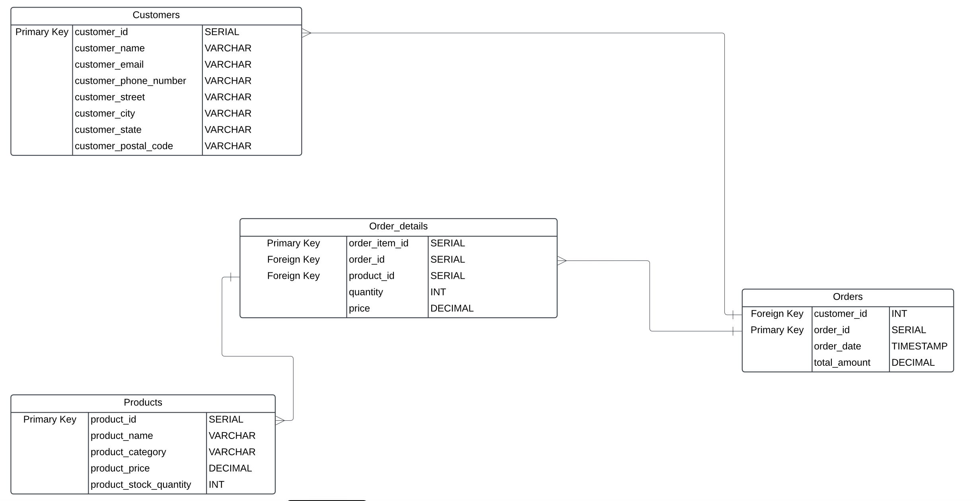

Revenue Analysis
Total generated revenue
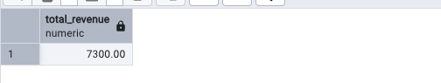

Revenue generated per product

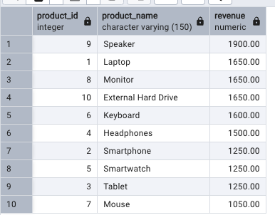

Customer Insights:
- List the top 5 customers by total spending.

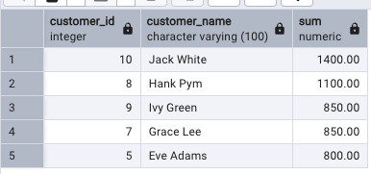

- Identify customers who haven’t made any purchases.
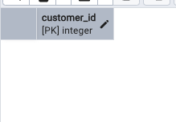
-- 1. Top 3 best-selling products
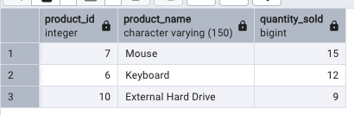

- products that are out of stock
